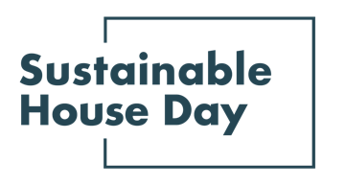 | 

Press Release — 2nd March 2023

Sustainable House Day is back and bigger than ever

Sustainable House Day is back for another year, with plenty of ways for Australians explore some of Australia’s most unique and inspiring homes, and learn from the people who designed them, built them, and live in them.

Established in 2001, Sustainable House Day is a national event program that facilitates peer-to-peer knowledge sharing on sustainable building, design and living by providing access to Australia’s best sustainable homes.
This year, the Sustainable House Day program has been expanded into a month-long event. The main event on Sunday March 19th will feature online house tours of over 100 houses, eight free online sessions, and a range of nationwide community partner events including in-person house tours, factory walk-throughs, practical demonstrations, and panel discussions.
This day will be followed by a month of online Extension Sessions, offering a deep dive into topics across four main themes: From Concept to Design, Building Materials, Sustainable Heating and Cooling, and Technology for Sustainability.
With these events, Sustainable House Day will provide countless opportunities for education and inspiration for those looking to reduce their homes’ environmental impact, accessible to everyone across Australia.
“Sustainable House Day is dedicated to showcasing Australia's most inspiring sustainable homes, while providing information for all Australian's motivated to take the next step on their green-home journey, no matter who they are, or where they live.” Said Renew CEO Fiona Gray.

— END —

Sustainable House Day is organised by Renew, a national, not-for-profit organisation that inspires, enables and advocates for people to live sustainably in their homes and communities.

—
Bookings for our entire program are open on our website, sustainablehouseday.com
Sustainable House Day media contact: Diane Falzon, pr@dianefalzon.com, 0430 596 699

